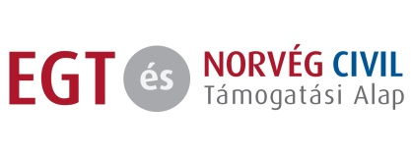
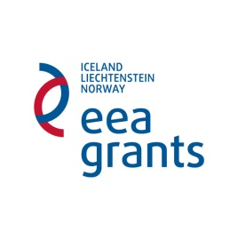

4 years, 448 projects –
Closing conference of the NGO Programme of the EEA/Norway Grants in Hungary (HU05)

6-7 April 2017, European Youth Centre Budapest

Draft program

6 April – ’Hungary Day’

10-11.00 Introduction
- Opening remarks of the donors’ representatives: Olav Berstad, Ambassador of Norway; Paivi Antilla, Senior Sector Officer, Financial Mechanism Office
- Opening remarks of the National Focal Point: Adrián Savanyú, Head of Department, Prime Minister’s Office Department for Implementation of International Co-operation Programmes
- Key facts and figures of the programme – Veronika Móra, programme director

11.30-13.00 Presentation of the programme evaluation – achievements and results
- In 3 parts, by members of the Fund Operator’s evaluation team – Roland Kelemen-Varga, team leader, Ökotárs – Hungarian Environmental Partnership Foundation
- Q&A

13.00-14.00 Lunch break

14. 00-15.30 Parallel sessions on cooperation between state institutions and civil society in the framework of the programme: - Representatives of state agencies and NGOs which worked together on supported projects will present the cooperation from their perspective in a panel discussion, followed by a Q&A

- Law enforcement
- Klaudia Makó Klaudia lawyer, Sex Workers Advocacy Association & Emese Kertész, lieutenant-colonel, National Police Headquarters, National Police Headquarters
- György Makula, Fraternal Association of European Roma Law Enforcement Officers & Tibor Lakatos, police colonel, Head of Department and Judit Varga, police major, Senior Referent, National Police Headquarters, Department for Public Order Protection
- Miriam Ekiudoko, Ebony African Association

- The penitentiary system
- Mercedes Mészáros, Changing Lanes Foundation & Eszter Tímea Tanács Dr, penitentiary colonel, Head of the Prison and Correctional Institute of Kalocsa
- Ágnes Kóka, Give Me Your Hand Association & Attila Juhász, penitentiary colonel, Head of the Prison of Eger
- Judit Hajdu, Speak Out! Association & János Gáspár, penitentiary major, Prison of Vác
- Viktória Tóth, Empty Space Theater Association & Katalin Koncz penitentiary major, Prison of Pécs

- Health care and social welfare
- Gábor Barnóczki, Borsod-Abaúj-Zemplén County Association of the Blind and Visually Impaired & Tamás Kisida Dr Equal Opportunities and Civil Referent, Municipality of Miskolc, Department of Human Strategy
- Márta Schermann, Last Line Art Association & Zoltán Horváth, Head of the Special Children’s Home Center, Primary and Vocational School
- Zsuzsanna Dallos, Aphasie Association & Pál Salacz Dr and Katalin Kitti Nagy representing the Péterfy Sándor Street Hospital and Emergency Center
- László Jakubinyi, Symbiosis Foundation & Csaba Árvai, Head of Department, Ministry of Human Resources, Department of Disability Matters

Questions to be discussed: How did the given state institution experience the cooperation with their NGO partners? How were the contacts and relations built? What are the impacts and benefits of the cooperation? How can the institution utilize the results in their future work? What could be improved? (The same questions will also be addressed by the NGOs from their point of view.)

15.45-17.00 Parallel sessions on the sustainability of NGOs and project results
Representatives of projects that achieved lasting results through different means will present their work and the success factors, followed by a discussion.

1) Volunteering
- Hajnalka Somogyi and Nikolett Erőss, OFF-Biennale Association
- Andrea Varga Andrea, ’Chrystal Valley’ Association for Regional and Rural Development
- Zita Jámbor, BAGázs Association
- Zoltán Végh, Uccu Roma Informal Educational Foundation

2) Fundraising through innovative means
- Ivetta Kovács and Péter Breitner, ’There’s Chance’ Foundation
- Zsuzsa Czunyi, Autistic Art Foundation
- Mónika Paulik, Project ‘No Means No’
- Zsuzsa Tóth, Fleece Foundation
- Anikó Haraszti, Association of Conscientious Consumers
- Anna Várnai, Colorful Beads Association

3) New grassroot movements
- Judit Surányi, Rehab Critical Mass
- Zoltán Havasi, Bike Mafia Association
- Pálma Fazakas, Birth-house Association

Questions to be discussed: What factors helped or played a role in the success? What has been achieved, how the work continued since the supported project was closed? What are the future perspectives? If sustainability could not be achieved, why – what would have been needed?

17.00-17.15 Plenary summary and closing 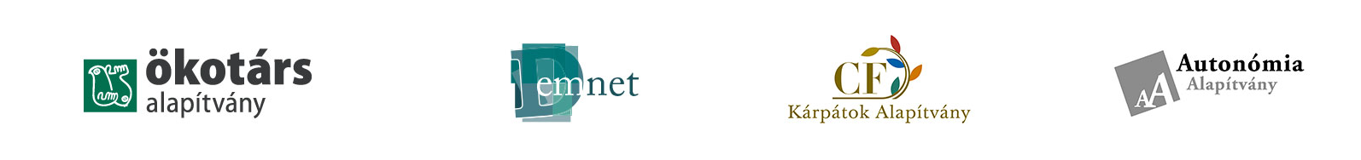

7 April – ‘International Day’

10.00-11.00 Keynote speeches: “Shrinking civil space” as a worldwide phenomenon and how do international and civic organizations do against it?
- The state of civil society worldwide: presentation of the CIVICUS Monitor – Marianna Belalba, CIVICUS
- The UN High Commissioner for Human Rights and civil society – Paul d’Auchamp, UN OHCHR, Head of the European Region (TBC)
- Human rights and civil society organization in Europe – Waltraud Heller, Programme Manager, European Union Fundamental Rights Agency
- Some perspectives from the donor community – Hanna Surmatz, Legal Counsel European Foundation Centre

11.30-12.30 Panel discussion: the experience in Central Europe – how shrinking civil space is experienced in this region, what are the impacts and practical consequences?
- With representatives of the Fund Operators in Poland, Slovakia, Romania and Bulgaria, moderated by Veronika Móra, followed by Q&A. Panelists:
- Ionut Sibian, Civil Society Development Foundation (RO)
- Ewa Kulik, Batory Foundation (PL)
- Elitsa Markova, Open Society Foundation (BG)
- Peter Medved, Ekopolis Foundation/Jan Orlovsky, Open Society Foundation (SK)

12.30-13.30 Lunch break

13.30-15.00 Presentations: what can be learned from NGO projects implemented in the region?
- Short presentations of best practice projects supported by the NGO Programmes in Poland, Slovenia, Bulgaria, Romania Greece and Cyprus
- Partly by the project promoters from the above countries, partly by staff members of the Hungarian Fund Operator who participated at study tours and met the projects firsthand. (Speakers TBC)

15.00-15.15 Closing remarks

